Practical No. 3
Aim : 6) WAP to swap the value of two variables.

Name : Danish Altaf Solkar | Class : CO - B
Enrolment no. : 24111590805 | Batch : 2

Code :-
a=int(input("\nEnter value for a: "))
b=int(input("\nEnter value for b: "))
temp=a
a=b
b=temp
print("\nAfter swapping: ")
print("\na: ",a)
print("\nb: ",b)

OUTPUT :-
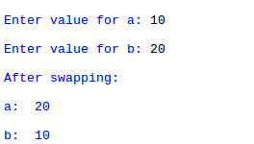

Process related  (30) | Product related  (20) | Total Marks  (50) | Signature

